|  |  |
| --- | --- |
| **Team Id** | PNT2022TMID46219 |
| **Project Name** | Natural Disaster Intensity Analysis And Classification Using Artificial Intelligence |

CYCLONE

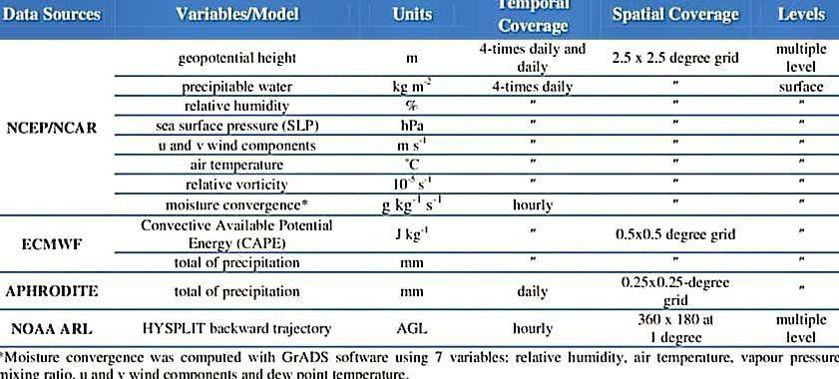

EARTHQUAKE

